GoogleFit registration

Added 02.08.2018.

1. To register an account, follow the link <https://www.google.ru/>.

2. In the window that opens, click on the "Sign in" button.

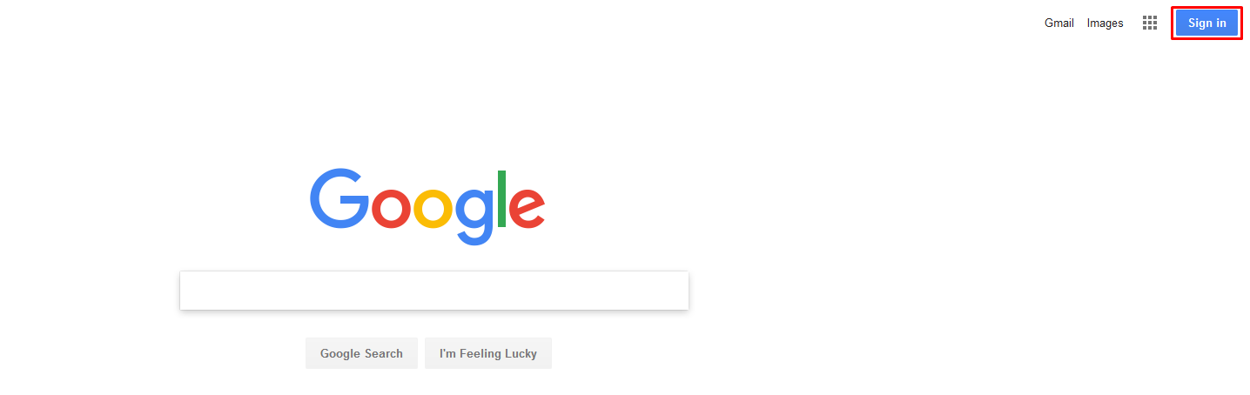

3. Then click on the "Create account" link.

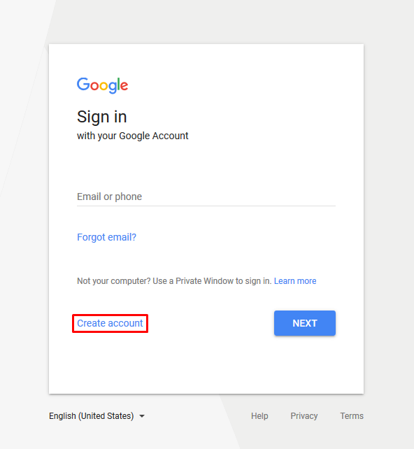

4. Fill in the required data and click on the "Next" button.

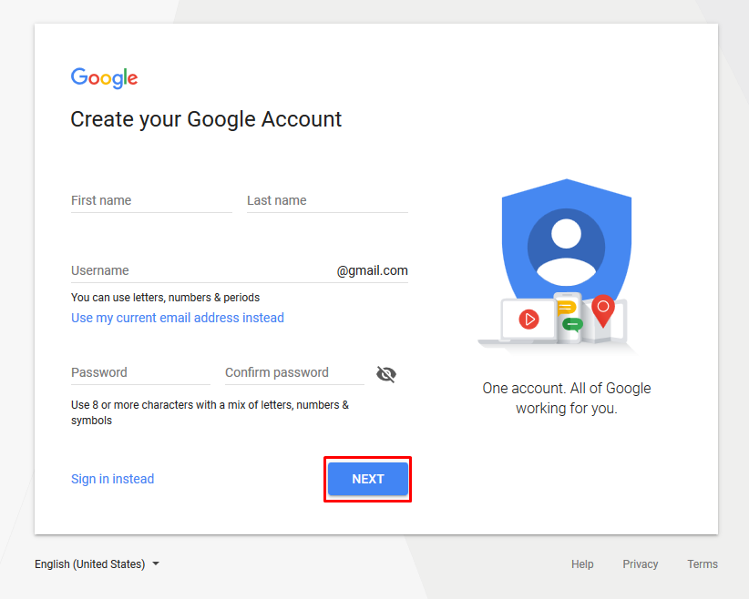

5. In the next window, specify the phone number, date of birth, gender and click on the "Next" button.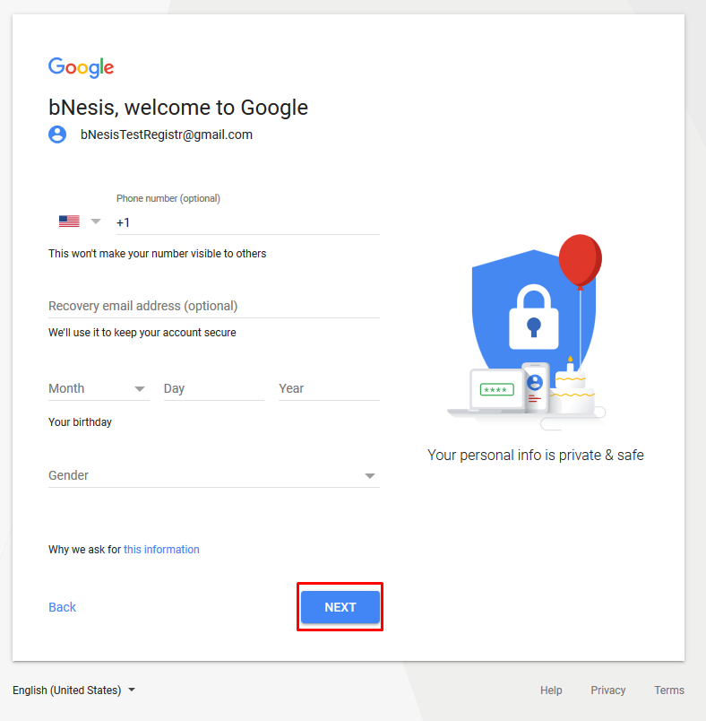

6. It is necessary to verify your phone number by clicking on the "Send" button.

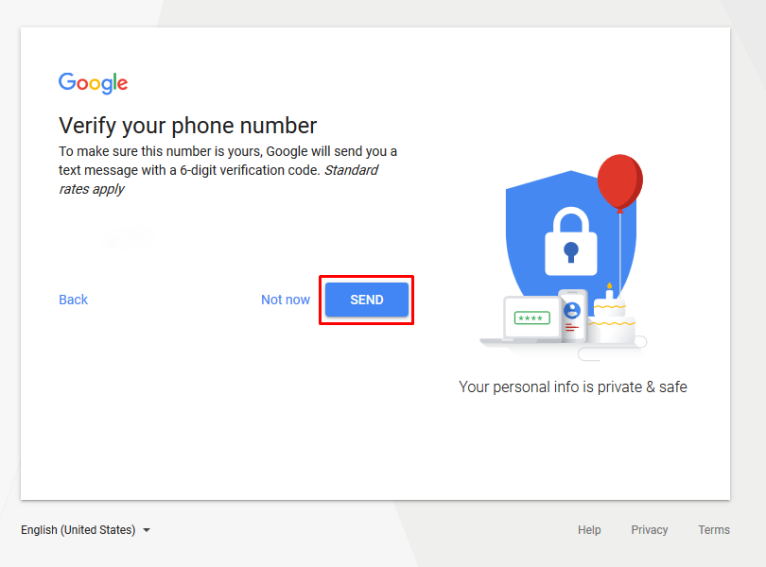

7. Specify the code that came in the SMS, and click "Verify".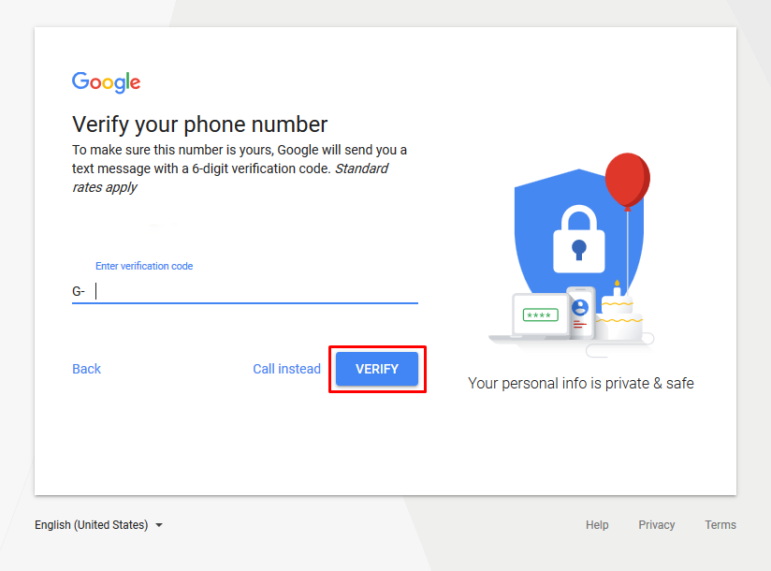

8. Read the license agreement and click on the "I agree" button.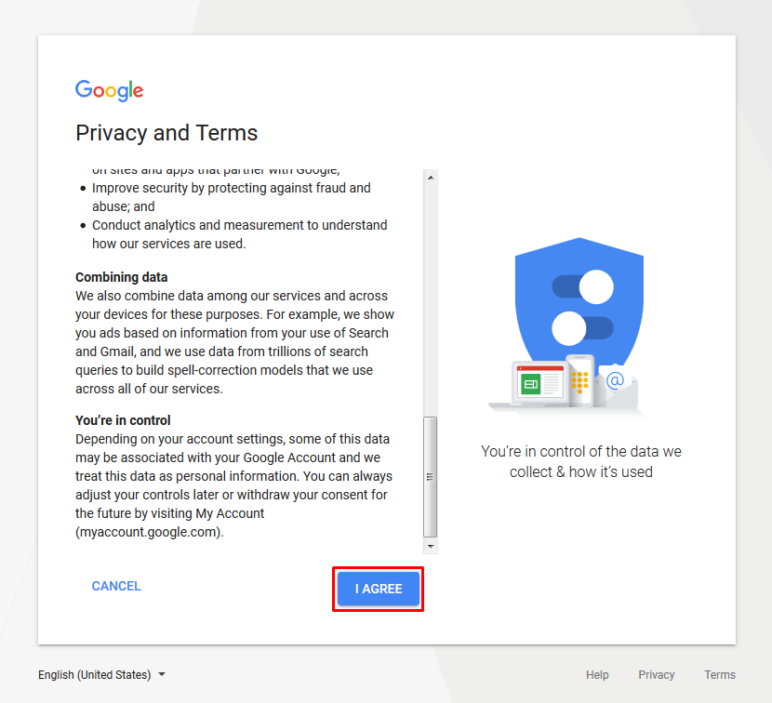

9. You have signed up for Google.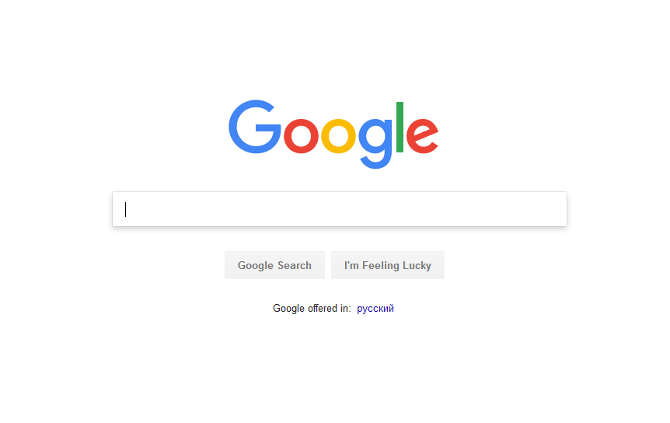

10. To register the application, follow the link <https://console.developers.google.com/>.

11. Click the "Create Project" button.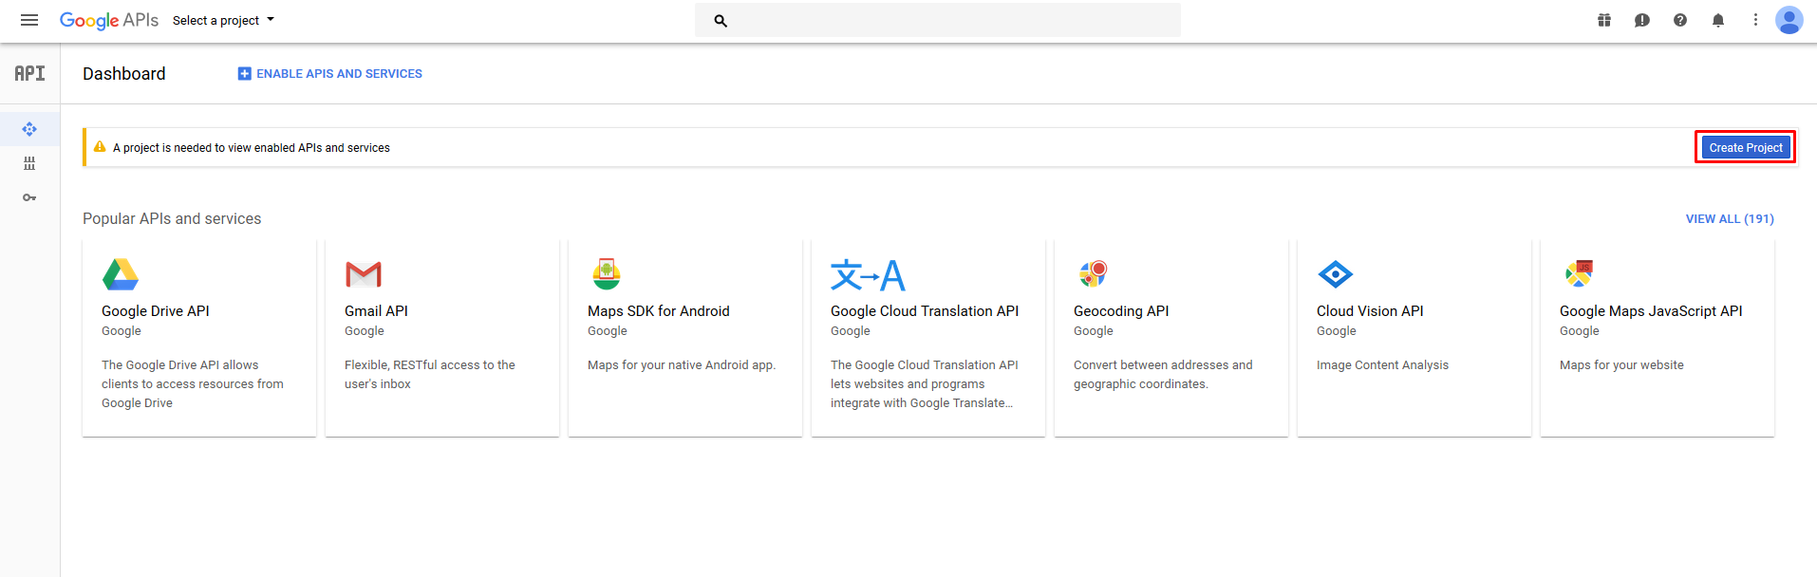

12. In the next window, click on the "Create" button.

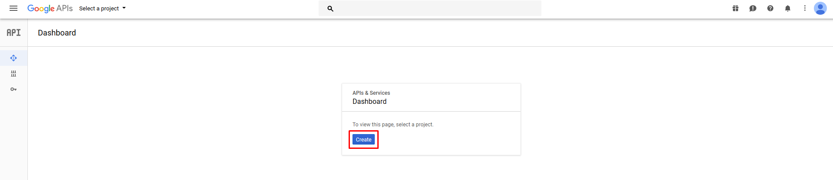

13. Specify the name of the project and click on the "Create" button.

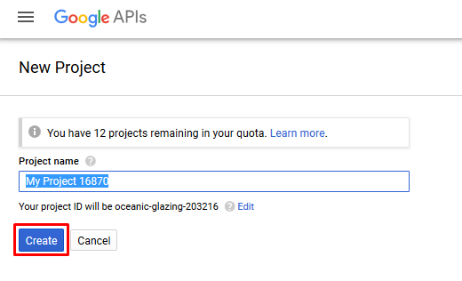

14. Go to the "Library" category.

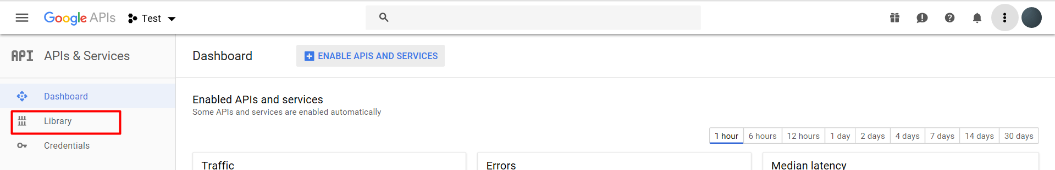

15. Here you need to select the service you are interested in.

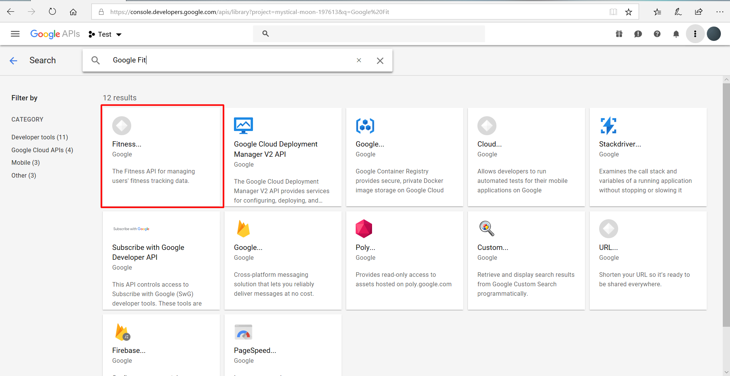

16. On the next page, turn on the API by clicking on the "Enable" button.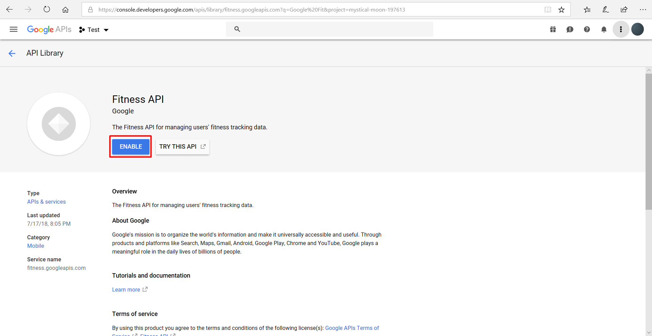

17. Next you will be redirected to the settings window of the selected service, click there "Create credentials" button.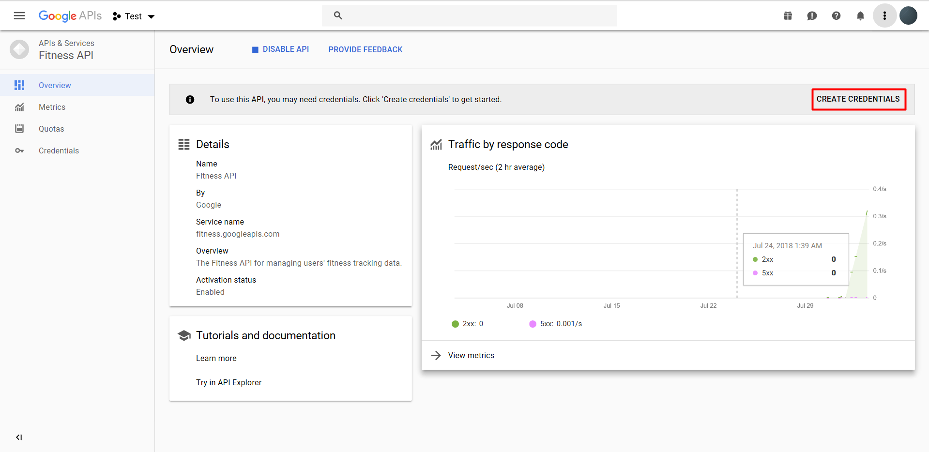

18. Make the initial settings and click on "What credentials do i need?".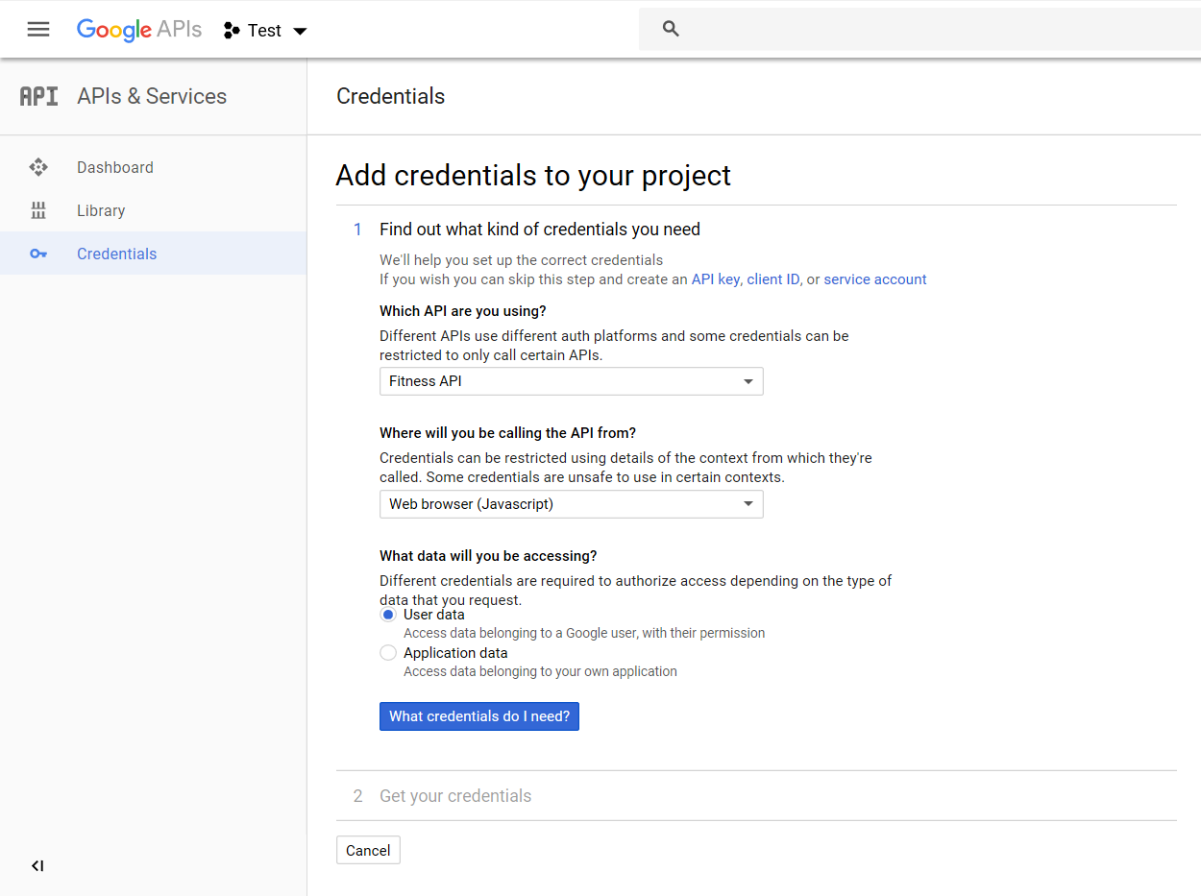

19. In the next window, specify Redirect URL and click on the "Create OAuth client ID" button.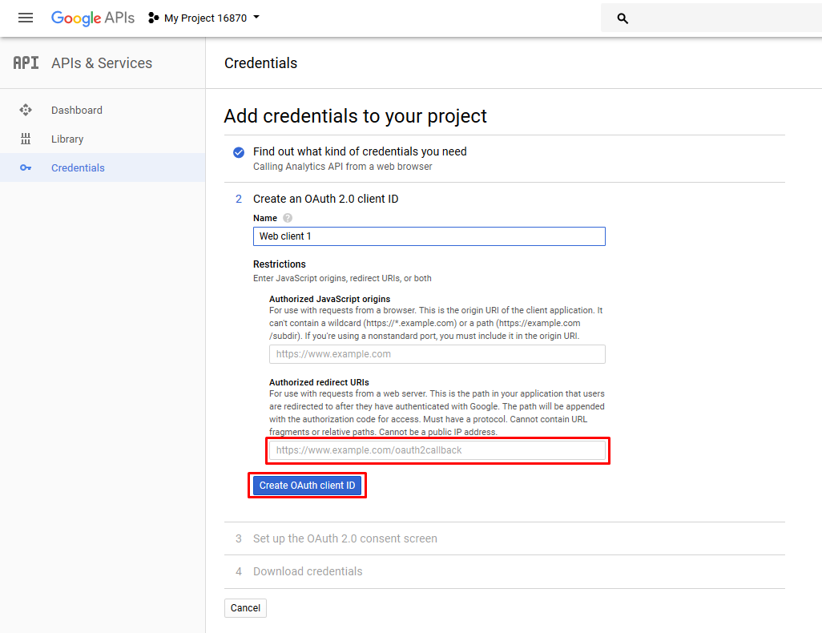

20. In the next window, specify «Product name shown to users» and click the «Continue» button.

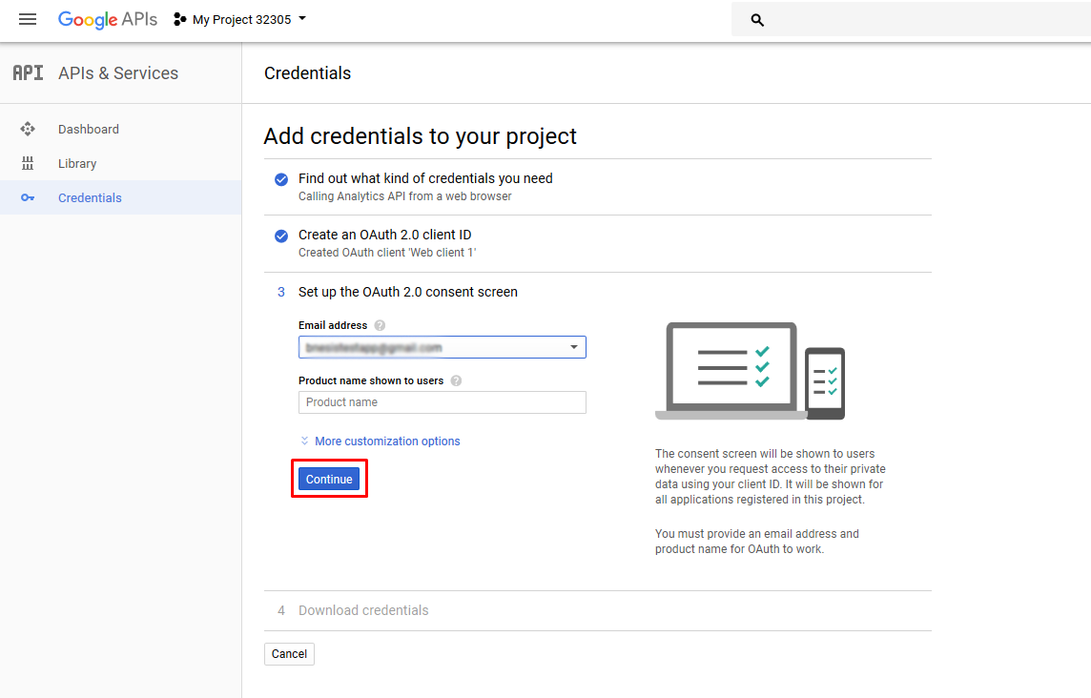

21. Now you can download the required Client ID and Client Secret by clicking on the "Download" button, then click on the "Done" button.

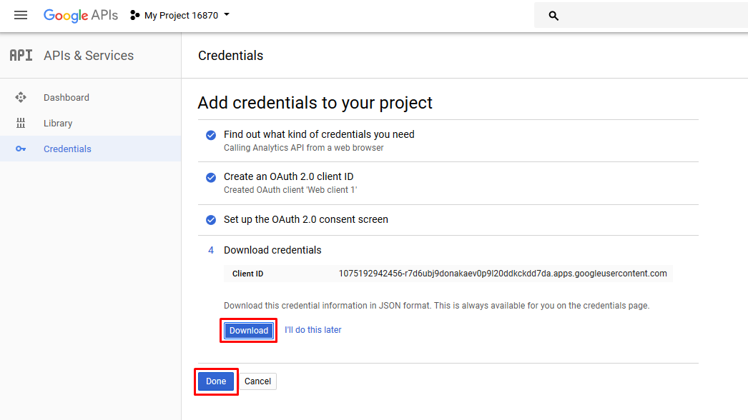

22. The settings have been made.